**Instructions for loading test data into the database**

We are using MongoDB to store the information that is used for our application. Following are the steps.

**Step 1:** Open command prompt and go to the bin location where mongo is installed and type the command mongod.exe and press enter. A server opens and waits for connection on port 27017.

Commands used: **mongod.exe**

**Step 2:** Open another command prompt and navigate to bin location of mongo and type the command mogo.exe and press enter. The shell is connected to the port and is ready to use.

Commands used: **mongo.exe**

**Step 3:** Use command “show databases” in the shell to see the databases already in. Type “use testgdp” to use the testgdp database(if testgdp is not present, one is created for you with the name testgdp).

Commands used: **show databases,**

**use testgdp**

**Step 4:** Use command “show collections” to see the collections present in testgdp database. To create a collection and insert the data, use the command “db.employeeDetails.insertMany([data])”.

Commands used: **show collections,**

**Db.employeeDetails.insertMany()**

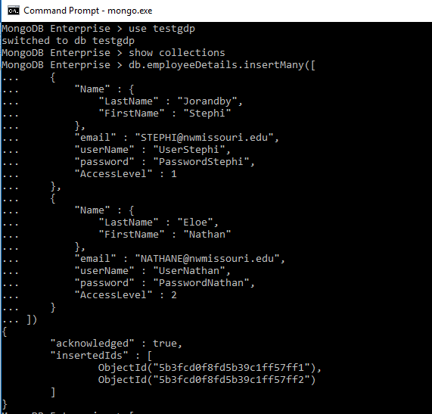

**Step 5:** To view the stored data, use the command “db.employeeDetails.find()” . Use “db.employeeDetails.find().pretty()” for proper visual representation of the data.

Commands used: **db.employeeDetails.find(), db.employeeDetails.find().pretty()**

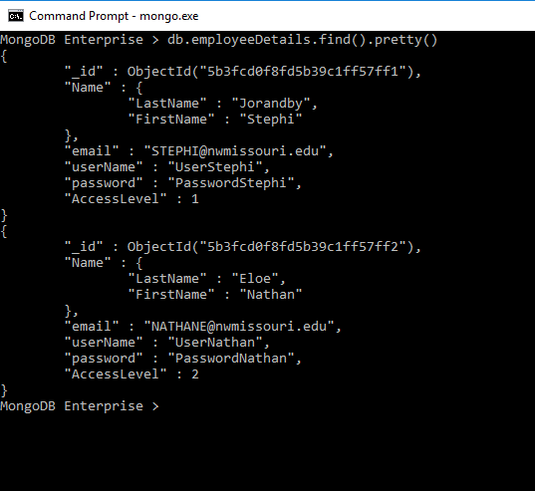

**Step 6:** Use steps 5 and 6 to load other data into the database

Other data: Performer information

Performer Measurements

Play details

Designer pull list

Shop pull list